**Standard Grid for Contact Search Results**

**Introduction**

This document explains about the contacts grid that is to be implemented throughout SmartTouch NextGen application. This layout is available wherever the user has to navigate from the search results, of any report, to the contacts list associated to the search results.

The primary objective is to be able to perform necessary actions to the associated contacts that are fetched by running the report.

**The Grid**

Here is a representation of the grid layout and the various options that shall be available.

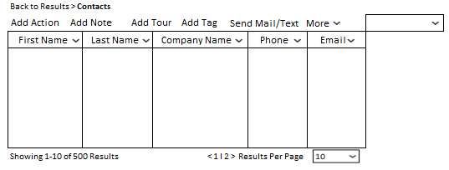

***The above snapshot depicts the grid layout for contact search.***

**Functional Expectations**

**Navigation Breadcrumb:** The breadcrumb at the top shall allow the user(s) to help them get back to the search results of the report.

**Column Selection:** The preferable columns shall be selected from the dropdown that shall list all the field names available on the Contacts Form for the Account.

**Note:** Any new custom field that is added shall reflect in the list.

**Sortable Columns:** Each of the columns in the grid shall be sortable in ascending as well as descending order of the contents in the selected column.

**Column Sizing:** Each of the columns should be flexible enough to manually adjust the width (by dragging the column separator) as per the contents.

To the bottom of the grid shall display the details as to the number of results being shown while on the other end shall be the pagination options. The user shall have the options to select the paginations as per the standard options that are available.

Additional options such as – Add Action; Add Note; Add Tour; Add Tag; Send Text/Email; More (Delete Contact, Export Contact, Add Opportunity, Add Relationship) shall be available for adding flexibility.

It is to be noted that the Contacts are only editable from the Contacts module only.